March 21, 2011

To whom it may concern:

The New Mexico Energy, Minerals and Natural Resources Department (EMNRD) has proposed to eliminate rockhounding in Rockhound State Park near Deming, New Mexico. The entire plan may be read at the following web site: http://www.emnrd.state.nm.us/PRD/documents/RockhoundPMPPublicReviewDraftMarch2011.pdf

I could not disagree more with this proposal as is unwarranted, takes away a decades-old privilege to millions of citizens and would do great harm to the local economy when rockhounds stop flocking to Deming to visit the park. To further make my argument against the plan, the following is my version of a point-counter-point with the actual text of the proposed plan that pertains to the discontinuation of rockhounding in the Park. The text (points) of the proposed plan is in italics with my counter points inserted in bold.

Rockhound State Park was originally established as a destination for rock collectors. It has been brought to my attention by a long-time Luna County resident who lives very near the Park, that Edgar May gifted the land to the State of New Mexico with the stipulation that it be turned into a park expressly for rockhounding. The authors of the proposed plan failed to mention this important historical information.

At the time, in 1966, rock collecting was a popular pastime. Visitors were encouraged to visit the Park in order to collect rocks, and were allowed to take home up to 15 pounds of rocks. Rockhounding continues to be a very popular pastime enjoyed by perhaps millions of people across the country, but especially in New Mexico.

Today the Division promotes a respect for the natural environment through interpretive and educational programs. Not only does rock collecting in a public park contradict the principle of natural resource protection. Collecting and preserving rocks and minerals by rockhounds actually protects a natural resource from natural processes (erosion, dissolution, oxidation, etc.) that will ultimately destroy them. Rock and mineral specimens recovered by rockhounds will be forever enjoyed by others, including patrons of museums through the world, such as the world-renowned Smithsonian National Museum of Natural History in Washington D.C.
There is only one state park in the United States that permits rock collecting: Crater of Diamonds State Park in Arkansas, which has a 38-acre plowed field set aside for collecting. Actually, there are two state parks in the US (Rockhound State Park and Crater of Diamonds) that were established for rockhounding, and this has taken place at both with no reported problems for many decades. Rock collecting is also allowed in California State Parks unless specifically stated on the information board at the park entrance. Rockhounding is also permitted on many other State and Federal lands, including those managed by the National Forest Service and Bureau of Land Management. For instance, Round Mountain Rockhound Area in Arizona is administered by the BLM.

Nearly all municipal, state, and national parks prohibit the removal of natural artifacts from parks. Even if true, this has nothing whatsoever to do with Rockhound State Park.

The practice of rock collecting at the Park would need to comply with NMSA 1978, Section 16-2-32: “A person who commits any of the following acts is guilty of a petty misdemeanor and shall be sentenced in accordance with the provisions of Section 31-19-1 NMSA 1978: A. cut, break, injure, destroy, take or remove a tree, shrub, timber, plant or natural object in any state park and recreation area, except in areas designated by the secretary and permitted by regulations adopted by the secretary, such regulations shall only permit the removal of a tree, shrub, timber, plant or natural object for scientific study or for non-commercial use by an individual as a souvenir, the quantity of material authorized for removal from any area shall be strictly regulated by park personnel in order to minimize resource damage.” This regulation was instituted in 1978, 12 years after Rockhound State Park was established. Clearly, there was, at the very least, an implied exception to this rule for the Park as rockhounding continued to be encouraged by park officials for the three-plus decades that followed.

If the Division were to continue to allow the public to collect rocks at the Park, the EMNRD Cabinet Secretary would designate a specific area and adopt rules pertaining to the collecting of rocks on Park property (such as the amount and location). Rockhound State Park, in its entirety, was established in 1966 as an official rockhounding site. Each visitor is limited to 15 pounds each per day, a small amount when considering the weight of rocks. Most rockhounds do not dig, but simply walk around picking up rocks and minerals from the ground surface. Actual digging in the park is confined to a relatively small area well away from the campground and well above the highest improved trail. For the most part, the only people who see the diggings are the relatively few rockhounds who are able and/or willing to make the strenuous hike up the steep rocky slope. Therefore, the location and amount have long since been established.

The once popular hobby of rock collecting has declined significantly since the 1960s. This is not true; as stated above, rockhounding continues to be a very popular pastime enjoyed by millions of people of all ages. The American Lands Access Association (ALAA) was established in 1992 to promote and ensure the rights of amateur fossil and mineral collecting, recreational prospecting and mining, and the use of public and private lands for educational and recreational purposes; and to carry the voice of all amateur collectors and hobbyists to elected officials, government regulators and public land managers. The ALAA represents over 52,000 members of 640 rockhounding clubs of the American Federation of Mineralogical Societies and many, many millions more unaffiliated rockhounds.

There are local businesses that cater to rock collectors and can guide or direct them to similar opportunities outside of the Park. The rocks and minerals in Rockhound State Park are unique and, as such, can be found nowhere else on Earth. According to the New Mexico Bureau of Geology and Mineral Resources, gray perlite, thundereggs, geodes, jasper, onyx, agate, crystalline rhyolite, Apache tears (obsidian), and quartz crystals are among the more common rocks and minerals found in the park. Thompsonite, a zeolite, is found in amygdules in quartz latite. Agate is present in a wide range of colors and is one of the minerals that many visitors collect at Rockhound State Park. Some thundereggs and geodes found at Rockhound contain multicolored agate in addition to well-formed quartz crystals. Tiltage thundereggs, locally found at Rockhound State Park, are filled with horizontal layers of agate and chalcedony that are overlain by concentric-banded agate and chalcedony; the contact between the layered and banded agate resembles an angular unconformity. These thundereggs record either small local landslides or tilting of local fault blocks within the Little Florida Mountains while the crystals were precipitating from the fluid. Thundereggs and geodes cannot be distinguished from one another until they have been broken apart. The beauty of a thunderegg or geode is locked inside the hard, rough-textured outer shell.

Safety is also a concern with the public collecting rocks in the Park, as there are steep and unstable slopes that are becoming more hazardous as the collecting alters the stability of the hillside. To my knowledge as a geologist and past visitor to the park, there are no unstable slopes, save for some minor talus slides. Digging has taken place in the park for over 45 years with no degradation to the stability of the hillside. Also, to my knowledge, there is no record of any significant injury to any rockhound.

There is also a concern that some visitors may go beyond the Park boundaries in their quest for rocks. The Park’s location was specifically chosen to coincide with a finite area abundant with collectible rocks and minerals. The productive collecting area inside the park is self-limiting, in that it ends at a certain point. Therefore, it is counterproductive to go beyond the Park boundaries in a “quest for rocks”. It should also be noted that the area where the vast majority of rock and mineral collecting takes place, including some digging, is confined to a relatively small area within the Park, as illustrated in the following map (main collecting area outlined and highlighted in red).

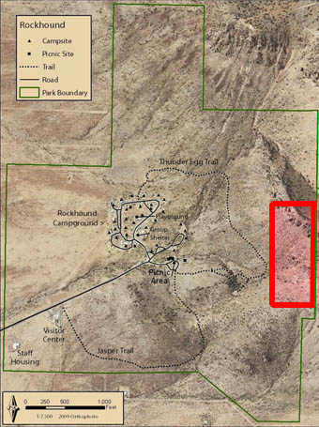
Park staff has already begun the transition away from rock collecting and will need to educate the public about the need to respect the natural resources. Park staff does what it is directed to do. No group, as a whole, has more respect for natural resources than rockhounds, but realizes this country’s “resources” belong to its citizens and are to be enjoyed. After all, a resource needs to be consumed to obtain any benefit from it and the rocks and minerals at Rockhound State Park are an inexhaustible resource.

One crucial step is to modify all Park information (signage, brochures, website), so that this activity is no longer encouraged. All materials need to state that it is a prohibited activity. The namesake theme can continue through educational programs and interpretive information about the rocks that occur in the Park and the geology of the region. Revise written materials by removing all mention of rock collecting and add a reference to the state statute which prohibits rock collecting on Park property. Obviously, none of this will be necessary if rockhounding continues to be allowed in the Park.

In addition to the above point counter point, I believe that it is important to present a brief rockhounding lesson, as it pertains to Rockhound State Park, to those who are unfamiliar with rock and mineral collecting, as seems to be the case with the authors of the proposed plan. Those with a lack of actual rockhounding experience may be under the misconception that scattered about the Park are brightly colored rocks and mineral formations that are being destroyed. This is simply not the case. Practically all the collectible rocks and minerals in the Park lay hidden inside rock formations or buried in plain looking dirt and rock. For instance the following picture shows the how unremarkable the rocks appear at one of the digging spots.

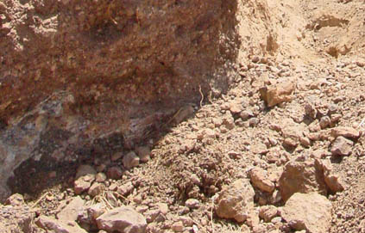
What may not be clear to an untrained eye in the previous picture are excellent rock and mineral specimens hidden amidst a pile of rock and dirt. What are necessary to reveal the rocks’ inner beauty are some cleaning, cobbing and/or cutting.

Another example of hidden inner beauty in Park rocks may be illustrated by the following pictures.

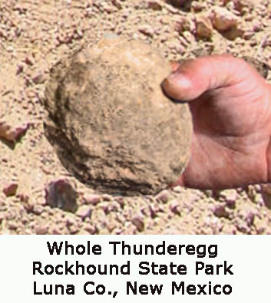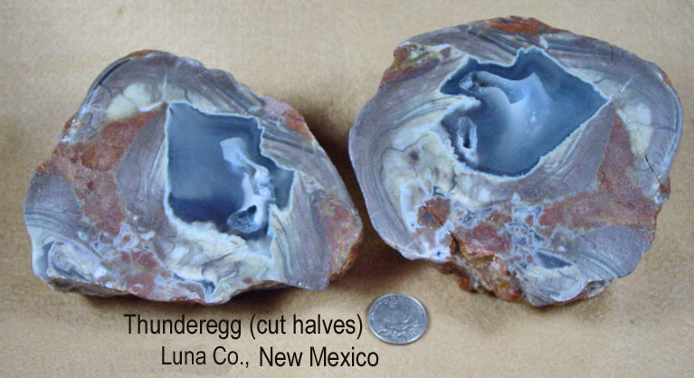

The above left picture shows a thunderegg as it was found in the Park and the above right picture shows what was revealed when it was cleaned, sliced in half, and polished. It often takes some rockhounding TLC for a rock to achieve its full potential. What a shame it’d be to leave these diamonds in the rough buried in the earth where nobody would ever be able to appreciate them; an absolute waste of a God given natural resource.

As you should be able to conclude, there is almost no merit to the proposed plan to discontinue rockhounding at Rockhound State Park; the concept of not allowing rockhounding in Rockhound State Park should make anyone with common sense shake his or her head in disbelief.

Michael Streeter
Professional Geologist
Southeast Federation of Mineralogical Societies’ North Carolina Director
http://www.McRocks.com

